**How to integrate nexus with Jenkins & store jar or war file in the nexus artifact.  
  
Step1:** Create the one nexus instances in aws or any cloud .  
  
**Step2:** login that created instances in aws from putty or any other thing.  
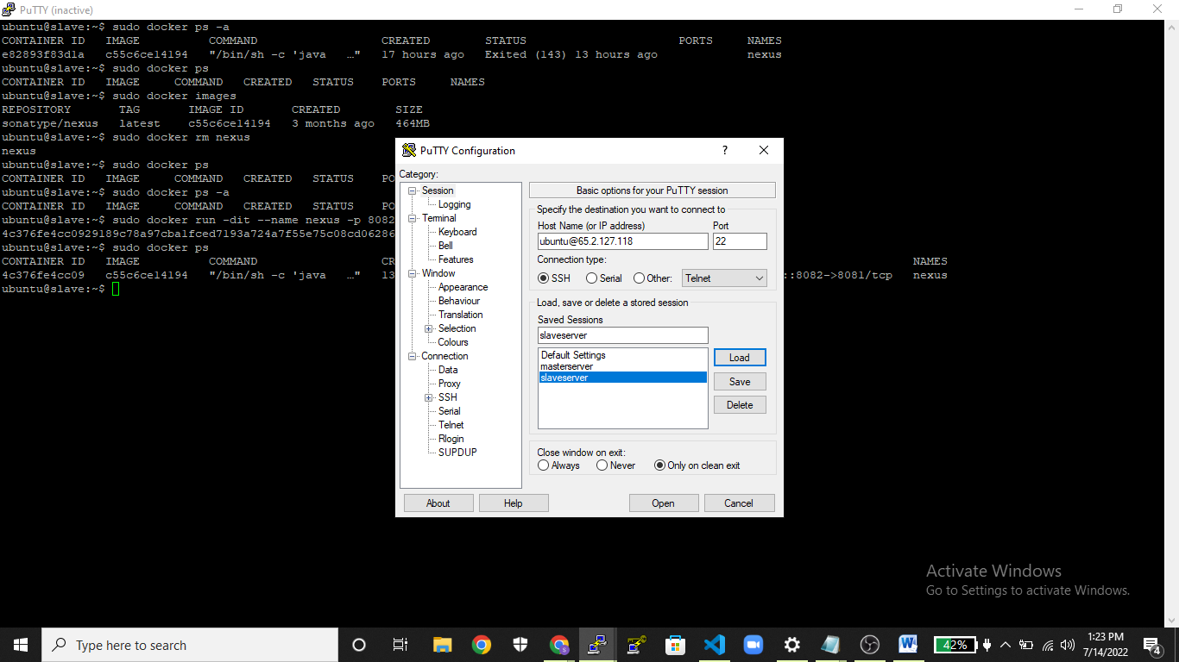  
  
**Step3:** install docker in nexus instances & pull the base image from dockerhub ( docker pull sonatype/nexus).  
***ubuntu@slave:~ $ sudo docker pull sonatype/nexus  
  
**step4:**  After building the nexus image then run that build image and start the container.  
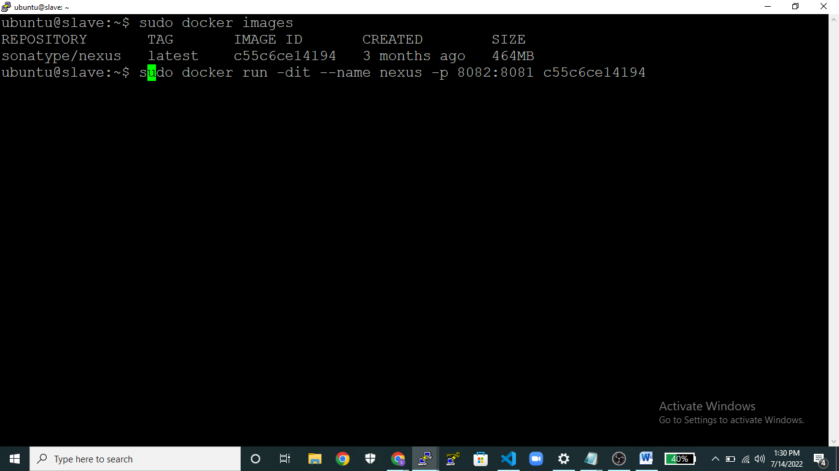  
  
**Step5:** After running the container login into the nexus repository and initially give the username as (**admin**) and password (**admin123)** and login the nexus portal page.  
  
**Step6:**  After login to the nexus portal page and then after create one user for that click on security and click on users where the option is presented on LHS of the portal page.  
  
 **Step7:** click on **add button** then select the **nexus user** option and provide the userid, firstname, lastname, email then select status as active and provide the password.

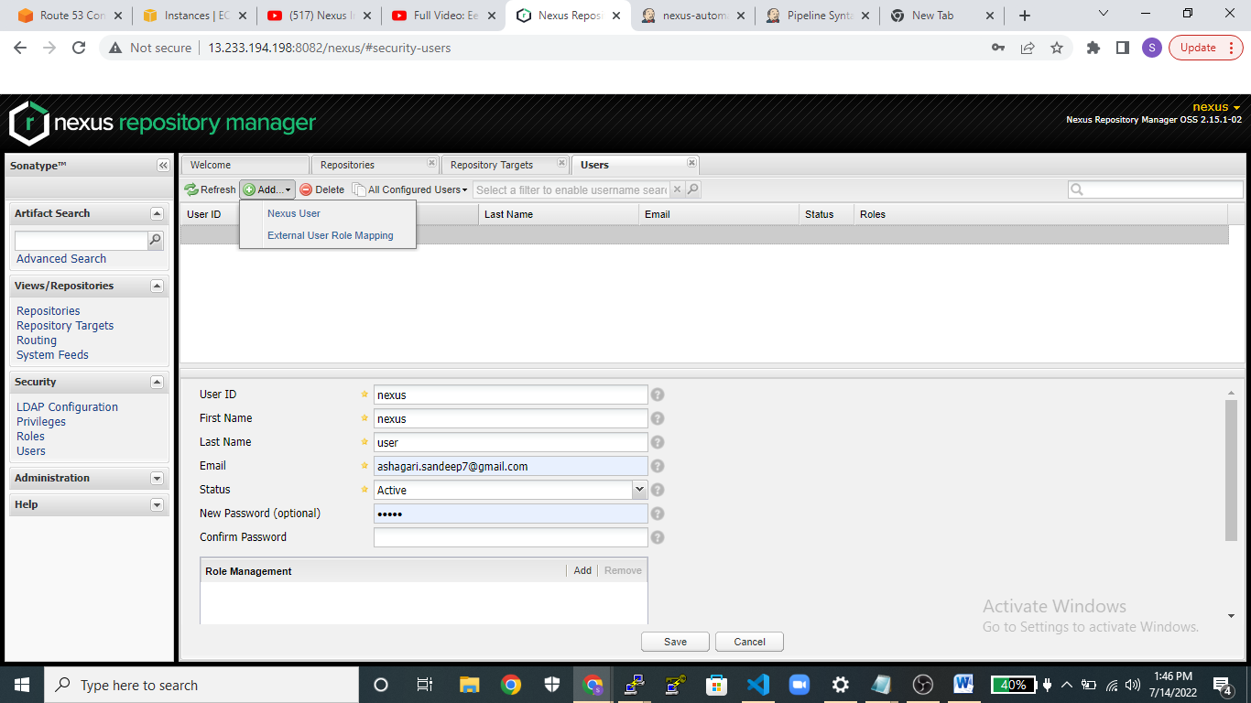  
  
**Step8:** Then goto **Role management** and clickon **add button** and select the role admin option .  
  
**Step9**: then again launch one more instance in aws and install Jenkins and java dependencies configuration things in that instance .  
  
**Step10**: Then after select the public ip:8080(portno). The Jenkins page will get open.  
  
**Step11**: Goto manage Jenkins an click on manage plugins and install the nexus artifact uploader.  
  
 **Step12**:Then create one newitem and provide the name then select the pipeline and save it.

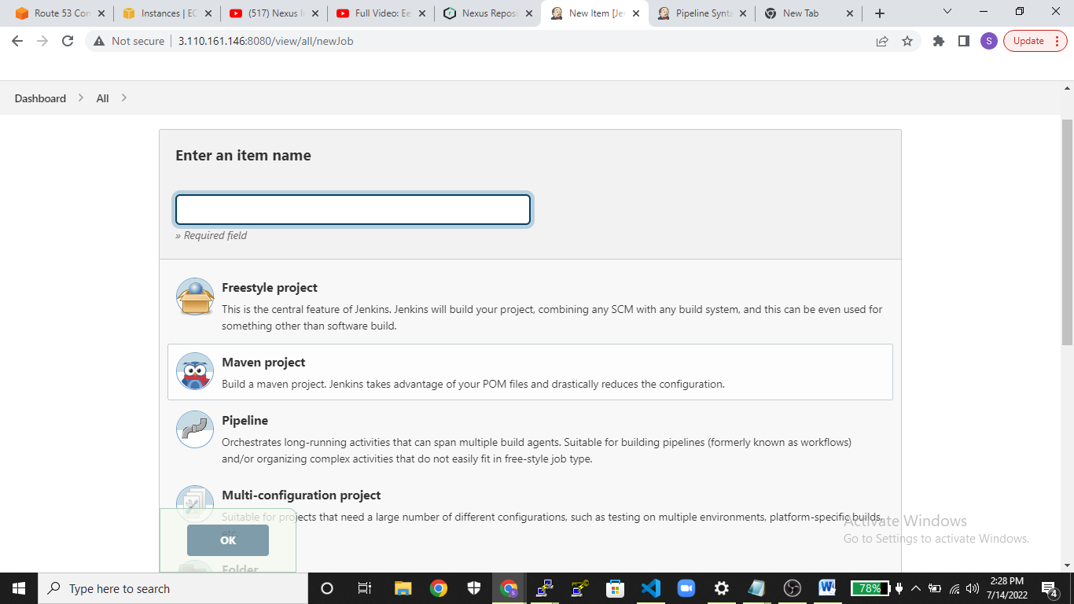  
  
**Step14**: After creating the project goto configure under pipeline definition select pipeline script . and give the below code.  
  
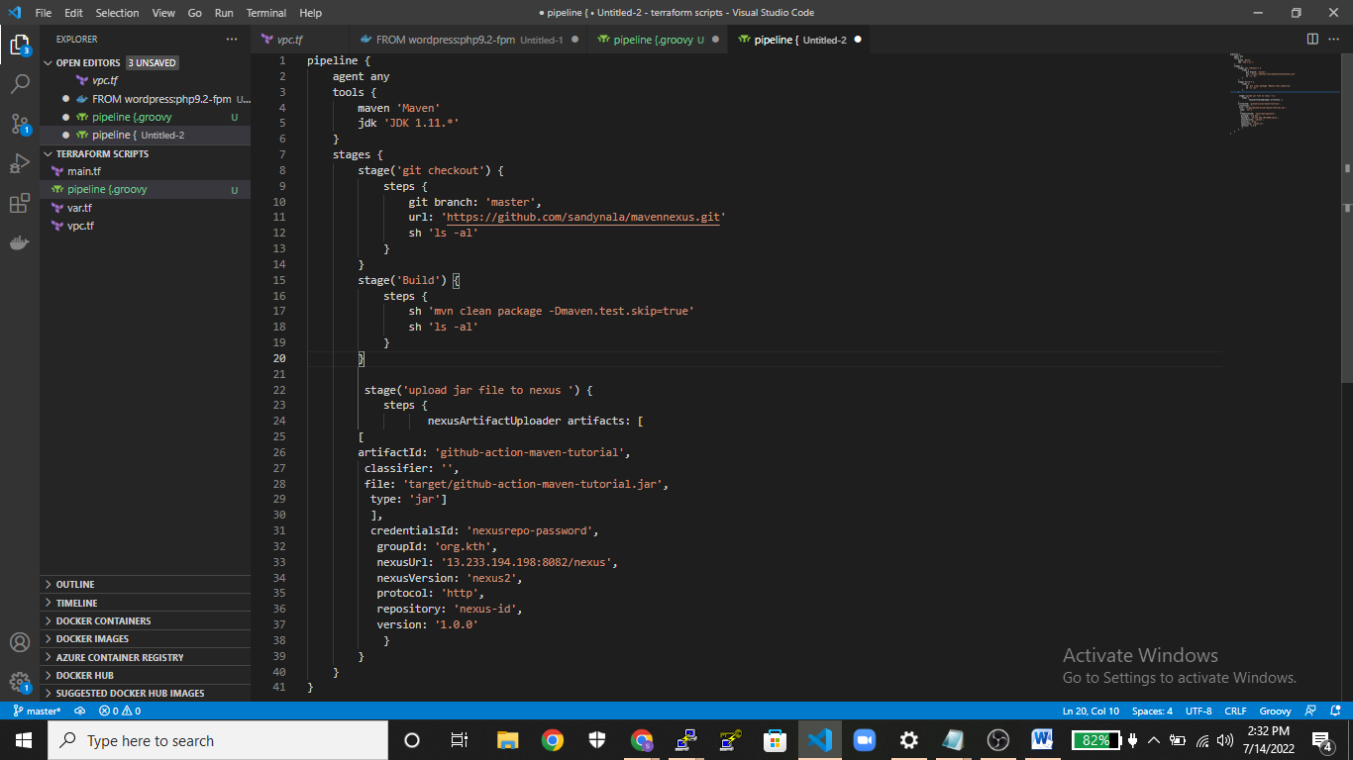  
  
 **Step13:** Then click on pipeline syntax  
** over there select the nexus artifact uploader in sample step   
** And in nexus version select it as nexus2.  
**protocol as http   
** provide the nexus url which is presented in nexus portal page under summary where you have created user in nexus repo.  
** create credentials in Jenkins for the go to credentials select kind as username with password and provide the user name and password of nexus only where you created in nexus portal page.  
** Group id give it from pom.xml which is mentioned in pom.xml file. And version   
** under Repository mention the nexus repository id which is available in nexus portal page under summary   
** Click on artifact mention the artifact id which is there in pom.xml and type as “jar”  
** File under give it as target/artifactid-version.jar(target/github-action-maven-tutorial-1.0.0.jar)  
** finally click on generate pipeline script then copy it and paste it on one editor and set the code in proper manner and copy that entire code into the pipeline script.  
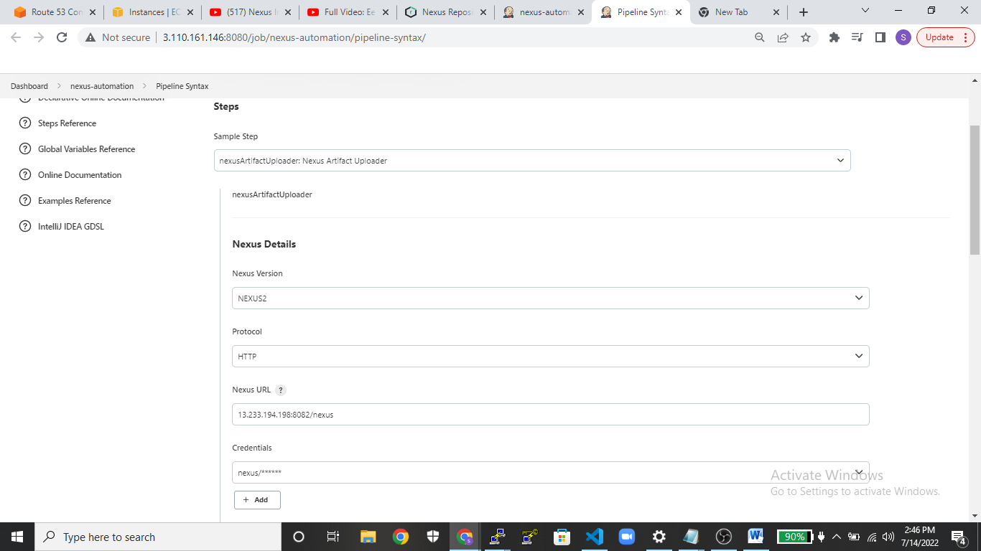  
  
**Step15:** Then finally build I and after that check the nexus repo whether that jar or war are pushed into that artifact or not.